Lab 02 Scala PCS-532

# Name : Devendra Johari

# Section : ML

# Roll No: 22

# University Roll No: 2015240

Program 1 : Hello World! In Scala

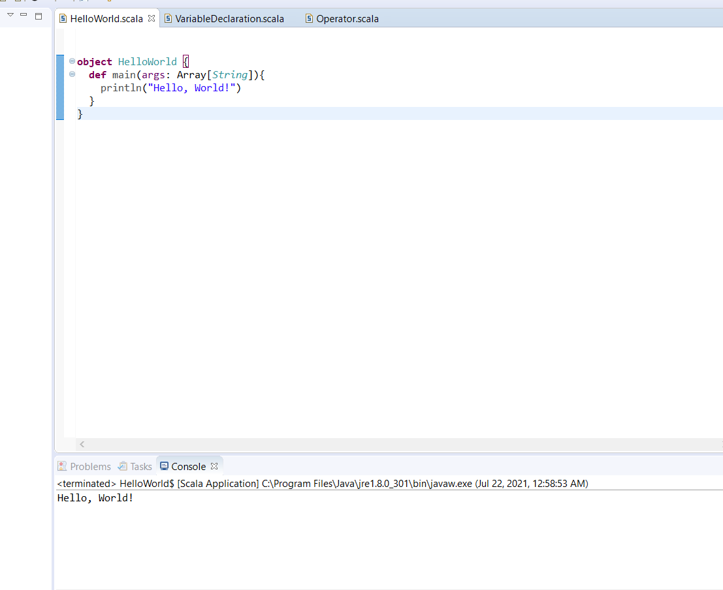

Program 2 : Variable Declaration

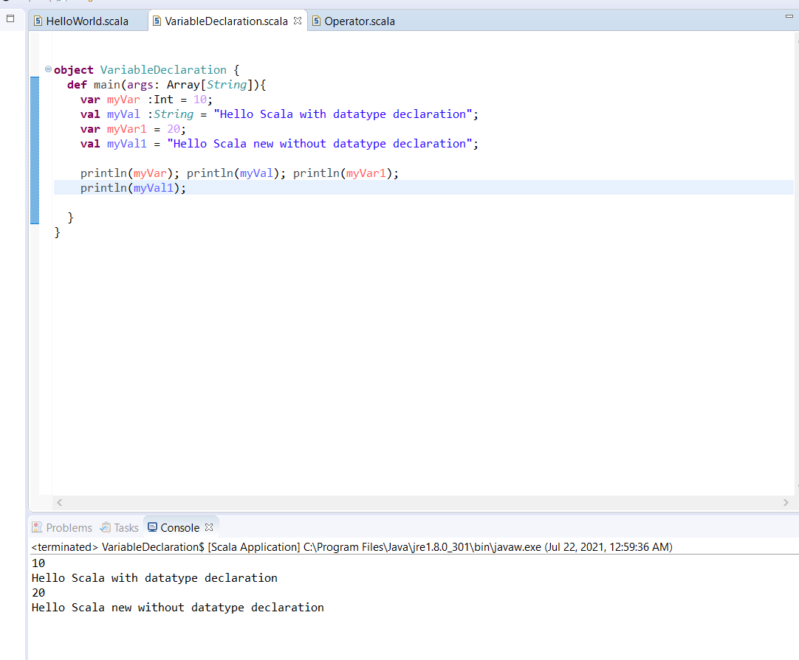

Program 3 : Variable Usage and Various Operator Usage, Inline Functions

